

#### Returns for Taxpayers



**Module Objectives**

###### After completing this module, you will understand:

* Overview of Returns
* Creation & submission of the monthly **GSTR 1** & **GSTR 2**
* Create GSTR 3
* Ledger
  + Electronic Cash Ledger (ECL)
  + Electronic Credit Ledger
  + Tax Liability Register
  + Mismatch Reports
  + Utilise cash & ITC

##### Overview of GST Returns



**Monthly**

###### GSTR 1 Statement of Outward Supplies GSTR 2 Statement of Inward Supplies GSTR 3 Monthly GST Return

##### GSTR 1, GSTR 2, & GSTR 3: Due Date for Filing

**GSTR 1**

10th of every month

**GSTR 2**

15th of every month

**GSTR 3**

20th of every month

**Who can file GST Returns?**

**Taxpayer**

**Tax** Practitioners

**Where can I file my GST Returns?**

**GST Portal**

[www.gst.gov.in](http://www.gst.gov.in/)

**Through a GSP**

GST Suvidha Provider

**GST Offline Utility Software**

##### GSTR 1: Statement for Outward Supplies

* + In the GSTR 1, invoices are uploaded by the Supplier Taxpayer.
  + Invoice uploaded in GSTR 1 for a financial year can be modified before filing of September GSTR 3 of next financial year or filing of annual return, whichever is earlier.
  + E-commerce sales transactions are captured explicitly in GSTR 1.
  + B2B & B2C transactions are captured separately in GSTR 1.

##### GSTR 1: Statement for Outward Supplies

* + A Supplier Taxpayer is required to prepare GSTR 1 wherein they will report invoice level information.
  + GSTR 1 needs to be filed even if there is no business activity (i.e. Nil Return) during the period of return.
  + Supplier Taxpayer will file return in electronic form only.
  + Invoices for IGST, CGST/SGST will be issued separately (in other words, one invoice can’t have IGST as well as SGST/CGST).
  + An invoice can’t have two different places of supply. POS should be a mandatory field in the inter-state invoice.
  + Bulk upload facilities are available for suppliers who have above specified entries per month.



**Returns for Taxpayers**

Designed and Developed by GSTN

**GSTR 2A: Draft of GSTR 2**

* The details of outward supplies furnished by the supplier shall be made available electronically to the registered persons (recipients) in **Part A** of **FORM GSTR-2A,** through the Common Portal after the due date of filing of **FORM GSTR-1**.
* GSTR 2A contains an auto populated list of all invoices received from all Suppliers Taxpayers’ corresponding returns for the given tax period; these invoices can be acted upon directly in the GSTR 2 before filing.
* Before filing the GSTR 2, Receiver Taxpayer shall take action on all the invoices received in the GSTR 2A.
* Receiver Taxpayer can accept, reject, & modify any pending invoices received in the GSTR 2A. Also, receivers can park items for next tax period & such items will roll over to next month’s GSTR 2.
* Accepted & Modified Invoices will flow to GSTR 2 & in case of Rejection only an intimation will be sent to Taxpayer & Tax Officer.

##### GSTR 2: Statement of Inward Supplies

* + Receiver Taxpayer can Add any missing invoices in the GSTR 2.
  + GSTR 2 is editable until receiver taxpayer has acted upon all the invoices received from all the supplier taxpayers (bulk approval/rejection is possible in GSTR 2).
  + Receiver taxpayer may choose to not act upon one or more invoices which will carry the ‘pending’ status & may be acted upon in subsequent tax periods.
  + After executing all the necessary actions, receiver taxpayer can file the GSTR 2.
  + GSTR 2 needs to be filed even if there is no business activity (i.e. Nil Return) during the period of return. Receiver Taxpayer will file return in electronic form only.
  + GSTR 2 can be filed only after 10th of the succeeding month. *Why?*

##### GSTR 1A: Addendum to GSTR 1

* + In the event of any amendment to an invoice or addition (in GSTR 2 of Receiver Taxpayer), the amended/added invoice(s) will auto populate the GSTR 1A of the Supplier Taxpayer.
  + This will happen in case of any error or discrepancy in the invoice level details at supplier’s end.
  + The Supplier Taxpayer can Accept or Reject the amended/added invoice.
  + If Supplier Taxpayer accepts the amendment/addition, their GSTR 1 will be auto-amended & liabilities will be updated accordingly.
  + In case they reject the amendment/addition, there will be no impact on their GSTR 1 & associated liabilities.

##### GSTR 1A: Addendum to GSTR 1

What will happen in case the Supplier Taxpayer rejects the amended invoice? It will lead to a mismatch. However, there are two possible scenarios:

1. **Upward** – Mismatch Report will be created
2. **Downward** – Supplier Taxpayer, Receiver Taxpayer & Tax Official(s) will be intimated

##### GSTR 3: The Consolidated Monthly Return

Hi, I am Vishal & I own an automobile workshop.



I file GSTR 1 for spare parts & services I supply to various customers.

I file GSTR 2 for all the spare parts I receive from various automobile companies.

I file GSTR 3, on the basis of GSTR 1 & GSTR 2 so my tax liability during the month is calculated while filing of GSTR 3.

##### GSTR 3: The Consolidated Monthly Return



Hi, I am Sumit, I run a transport agency. I have drivers on contract from ABC Drivers agency & I provide cab services for inter and intra state travels.

I file GSTR 1 & GSTR 2 every month.

I file GSTR 3, on the basis of GSTR 1 & GSTR 2 so my tax liability during the month is calculated while filing of GSTR 3

**GSTR 3: The Consolidated Monthly Return**

* Precondition - GSTR 1 & GSTR 2 must be filed successfully. *Why?*
* Summary of business transaction details for the tax period auto populated on the basis of GSTR 1 & GSTR 2.
* Must be filed even if there is no business activity (NIL Return).

**GSTR 1**

##### Monthly Returns: Data Flow

**GSTR 2/2A OF SUBSEQUENT TAX PERIOD**

### GSTR 2/2A

GSTR 5 (NRTP)

GSTR 6 (ISD)

GSTR 7 (TDS)

GSTR 8 (TCS)

***MODIFY ADDED INVOICE***

***ACCEPT***

#### GSTR 1A

***MODIFY or ADD*** ***REJECT***

***ACCEPT or MODIFY***



***REJECT***

**MISMATCH**

**FILE GSTR 2**

###### Filing GSTR 1: Demonstration Using Application – Preconditions

* 1. Taxpayer should be a registered taxpayer & have an Active GSTIN for the given tax period.
  2. Taxpayers should have valid login credentials (i.e., User ID & password).
  3. For cancelled GSTIN, taxpayer will have an option to file GSTR 1 for tax period during which there was business activity after the date of application for cancellation.
  4. Taxpayer should have an active (unexpired & unrevoked) digital signature certificate (DSC) in case of Taxpayer for whom digital signing is mandatory.
  5. Taxpayer should have a valid Aadhar number with mobile number if they opt for e-sign.

###### Filing GSTR 1: Demonstration Using Application



**Filing GSTR 1: Demonstration Using Application – Business Rules**

* + 1. GSTR 1 for the current tax period cannot be filed if GSTR 3 is not filed for the immediately preceding period.
    2. GSTR 1 can be filed only after completion of the calendar month except in the case of casual dealers
    3. Interest will be calculated for taxpayers on be daily or monthly based on final version of the law.

###### Filing GSTR 2: Demonstration Using Application



**Filing GSTR 2: Demonstration Using Application – Preconditions**

1. Taxpayer should be a registered taxpayer & have an Active GSTIN for the given tax period.
2. Taxpayers should have valid login credentials (i.e., User ID & password)
3. For cancelled GSTIN, taxpayer will have an option to file GSTR 2 for period after the date of application for cancellation; it will not be mandatory.
4. Taxpayer should have an active (unexpired & unrevoked) digital signature (DSC) in case of Taxpayer for whom digital signing is mandatory.
5. Taxpayer should have a valid Aadhar number with mobile number if they opts for e-sign.

###### Filing GSTR 2: Demonstration Using Application – Business Rules

* 1. GSTR 2 for the current tax period cannot be filed if GSTR 3 is not filed for the immediately preceding period.
  2. GSTR 2 can be filed only after 10th of the succeeding month except in the case of casual dealers.
  3. Interest will be calculated for taxpayers on a daily or monthly depending upon on final version of the law.

###### Filing GSTR 3: Demonstration Using Application – Preconditions

1. Taxpayer should be a registered taxpayer & have an Active GSTIN for the given tax period.
2. Taxpayers should have valid login credentials (i.e., User ID and password)
3. Taxpayer should have an active (unexpired & unrevoked) digital signature (DSC) in case of Taxpayer for whom digital signing is mandatory.
4. Taxpayer should have a valid Aadhaar number with mobile number if they opts for e-sign.
5. GSTR 1 & GSTR 2 for the given period must be filed successfully
6. GSTR 3 relating to earlier periods should be filed

###### Filing GSTR 3: Demonstration Using Application – Business Rules

1. Post generation of GSTR-3, the liability (tax/interest/late fees/penalty) of the Taxpayer & ITC will be computed & updated in then Tax liability Register & Electronic Credit Ledger.
2. If GSTR 3 is filed with Short/No Payment of liability, it will be treated as an Invalid Return & mismatch of recipients will be generated as if GSTR 3 for that tax period has not been filed.

Taxpayer’s Interface: **View E-filed Returns**

**1**



**2**

**Taxpayer logs into GST portal & clicks ‘View e-filed Returns’ in Returns section under the Services menu**

**On making the selection, the taxpayer will be able to view returns filed for a selected period as per the criteria in the screenshot**

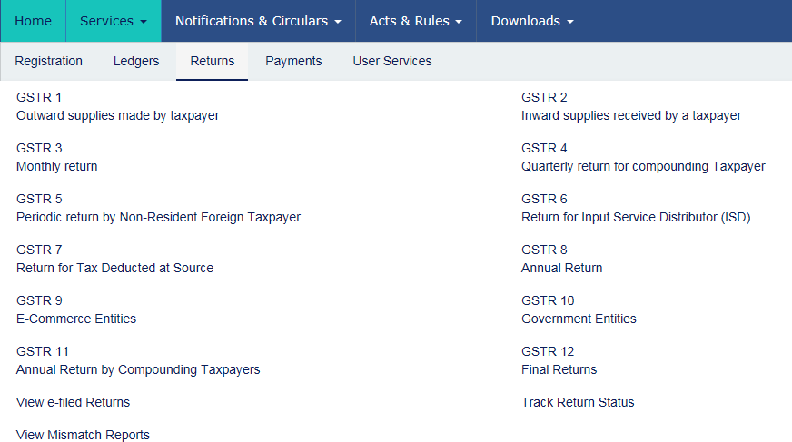

**3**



**Based on selected criteria, system will display valid returns filed during that period**

Taxpayer's Interface: **Track Return Status**

**1**



**2**

**3**

**Taxpayer logs into GST portal & clicks ‘Track Return Status’ in Returns section under the Services menu**

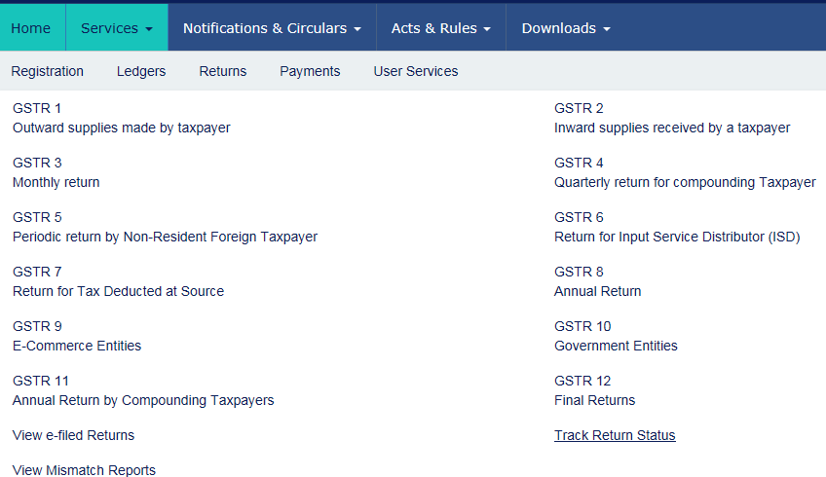

**Search page (screenshot) will allow taxpayer to search for Return through Status, Filing Period or ARN**

**Relevant result(s) are displayed & taxpayer can check the status**

###### GSTR 4: Composition Taxpayer Return

* Simplified Quarterly Return to be submitted by the Composition Taxpayer
* Similar to GSTR 2, details of inward supplies will be auto populated from counterparty GSTR 1 & GSTR 5 in GSTR 4A (equivalent of GSTR 2A)
* The composition tax payer will provide the summary of the outward supplies liable for composition levy
* GSTR 4 needs to be filed even if there is no business activity (Nil Return) during the period of return

###### GSTR 5: Non-resident Foreign Taxpayers

* Non- Resident Foreign Taxpayers shall be required to file GSTR 5 up to 20th of next month or within a period of 7 days from date of expiry of registration whichever is earlier
* Cannot avail ITC on local procurement
* Flow will be similar to GSTR 1 & so the GSTR 5 will auto populate GSTR 2A/4A/6A of Receiver Taxpayers

###### GSTR 6: ISD Return

* The Input Service Distributor is responsible for the distribution of Input Tax Credit to various units of the same legal entity having different GSTINs therefore, Taxpayer intending to distribute input services will be required to take separate registration as an ISD
* The ISD receives input service invoices on which it can avail ITC and then distribute the same to various other locations based upon the consumption of the services or any other method as the law may prescribe
* The GSTR 6 is auto populated from the draft GSTR 6A which is in turn auto populated by GSTR 1/5
* ISD can Accept, Amend, & Reject the entries in GSTR 6A & upon submission of draft GSTR 6A, GSTR 6 will be created & subsequently filed

###### GSTR 7: TDS Return

* A **TDS return** is a monthly statement of mandatory tax deductions made at source by a receiver (as per the laws proposed to be made in the GST regime) to a supplier’s payment.
* A taxable person has a legal obligation:
  + To declare their TDS liability for a given period (monthly) in the TDS return;
  + Furnish details of the TDS paid under four major heads viz., CGST, SGST, IGST & Cess in accordance with that return, &

###### GSTR 8: TCS Return

* GSTR 8 is a return filed by e-commerce portals who are required to do Tax Collection at Source on Net Supplies of the Goods or Services
* Amount collected has to be deposited to appropriate Central/State Government
* However, e-commerce portals supplying their own goods &/or services through their own portal will not be required to file this return in respect of such supplies
* Filing of NIL Return is not mandatory for E-commerce operators.
* Current rate of TCS is @ 1%

**Electronic Cash Ledger**

* Electronic Cash Ledger is an e-Wallet for all your financial transactions with the GST
* It is updated in near real time
* Electronic Cash Ledger captures all the details of amounts deposited to the exchequer & utilization of such amounts for the payment of tax liability, demand on account of mismatch, interest, penalties, fees etc.

Deposits

+

Payments

+

Record Keeping

##### Electronic Cash Ledger



**Cash Receipts (Credit)**

* Cash receipts using Online/other mode
* TDS
* TCS

IGST, CGST, SGST, Cess



* Tax
* Interest
* Penalty
* Fee
* Other Amounts

IGST, CGST, SGST, Cess

**Liability Payments (Debit)**

##### Electronic Cash Ledger: Important Note

* **Date of Deposit**: The date on which taxpayer deposits funds into the Electronic Cash Ledger
* **Date of Payment**: The date on which funds are utilised from the Electronic Cash Ledger to make a GST payment
* **Important**: *Date of deposit is not considered when calculating liabilities; only Date of Payment is considered*
* This means even if you have funds in your Electronic Cash Ledger, until you utilise these funds towards a payment, they will not be considered as payments made against your liabilities

##### Electronic Cash Ledger: Path

Location of Electronic Cash Ledger on the Taxpayer Dashboard (post-login)

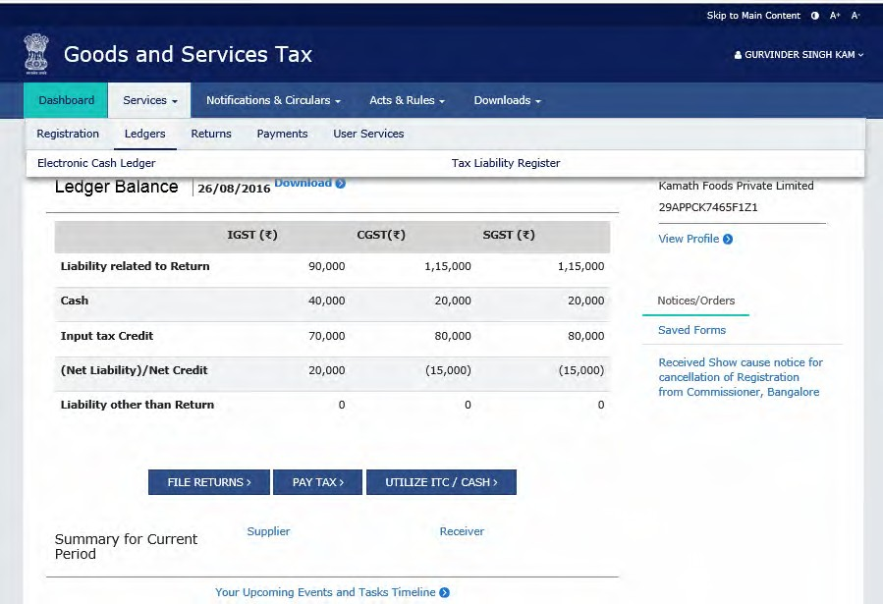

* 1. Click on **Services**
  2. Click on **Ledgers**
  3. Click on **Electronic Cash Ledger**

##### Electronic Cash Ledger: Landing Page

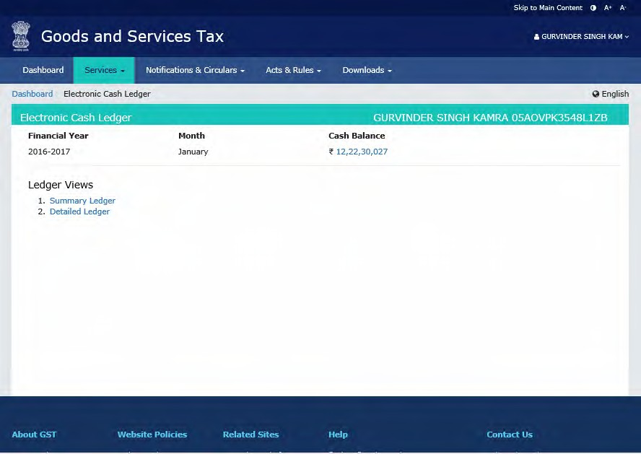

Ledger Balance

Ledger Views

* Summary View
* Detailed View

**Electronic Cash Ledger: Summary View**

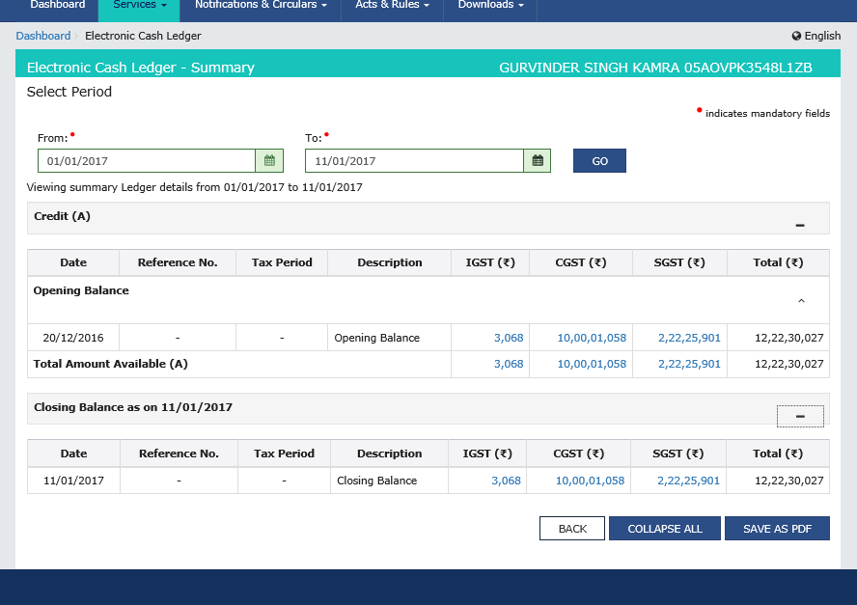

**Electronic Cash Ledger: Detailed View**

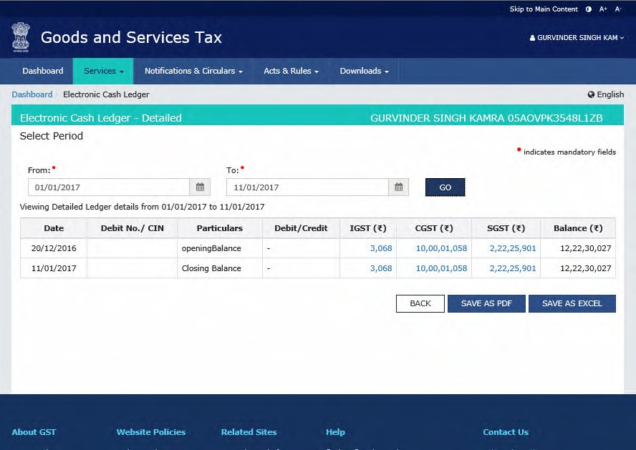

###### Creation & Maintenance of Electronic Credit Ledger

* *What is Electronic Credit Ledger?*
* The Electronic Credit Ledger is created by default when a taxpayer successfully registers under the GST regime except for those taxpayers who opt for composition scheme or registered for TDS/TCS
* Taxpayers under composition scheme cannot avail ITC

###### Creation & Maintenance of Electronic Credit Ledger

Where can I find the Electronic Credit Ledger in the GST Portal?



**Taxpayer accesses GST portal & reaches the landing page**

**Taxpayer logs into GST portal using their login ID & password**

**Taxpayer navigates through – Services > Ledgers >**

**& clicks on Electronic Credit Ledger**

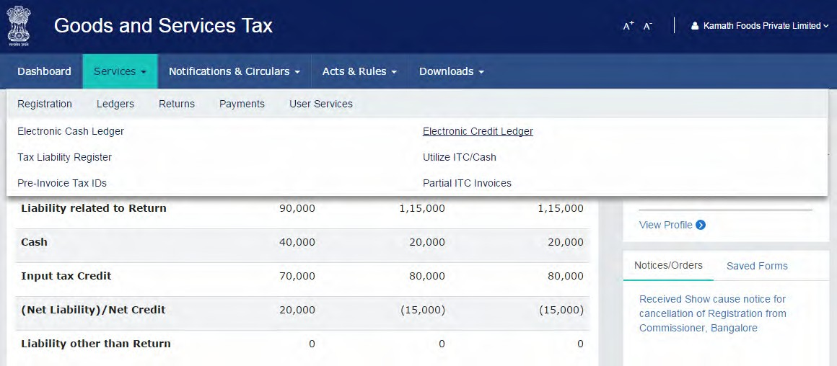

###### Creation & Maintenance of Electronic Credit Ledger

What happens when I click on Electronic Credit Ledger?

* + Landing page for Electronic Credit Ledger will be displayed & it will contain

1. ITC balance as on date
2. Option to view summary & detailed ledgers (similar to ECL)
3. Option to utilise available ITC

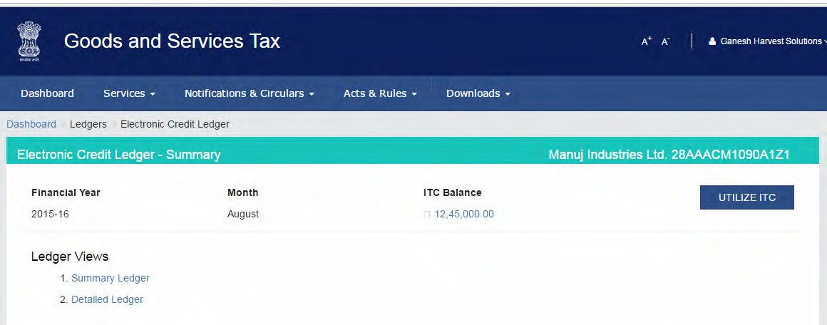

###### Creation & Maintenance of Electronic Credit Ledger: Business Rules

1. Period selected for which the ledger can be viewed can’t be more than six months.
2. No manual editing is possible in the Electronic Credit Ledger.
3. Electronic Credit Ledger cannot have negative balance.
4. On generation of GSTR 3, ITC of the current tax period will be available on provisional basis which can be utilised against return related liability in GSTR 3 of the current tax period only.
5. The Provisional credit will be maintained as a separate credit and displayed in Electronic Credit Ledger only for the purpose of utilization for making the payment of current tax period’s liability.

###### Tax Liability Register

* The Tax Liability Register will capture all the liabilities of the Taxpayer
* The liabilities will be auto populated through Returns for taxpayers or by tax officials for other liabilities from assessment or enforcement
* In certain cases, it may be populated by Tax Officials using the Tax Official’s Interface
* The Tax Liability Register is only for viewing by the Taxpayer because no manual entries can be made into the Tax Liability Register by the Taxpayer

###### Tax Liability Register

Where can I find the Tax Liability Register in the GST Portal?



**Taxpayer accesses GST portal & reaches the landing page**

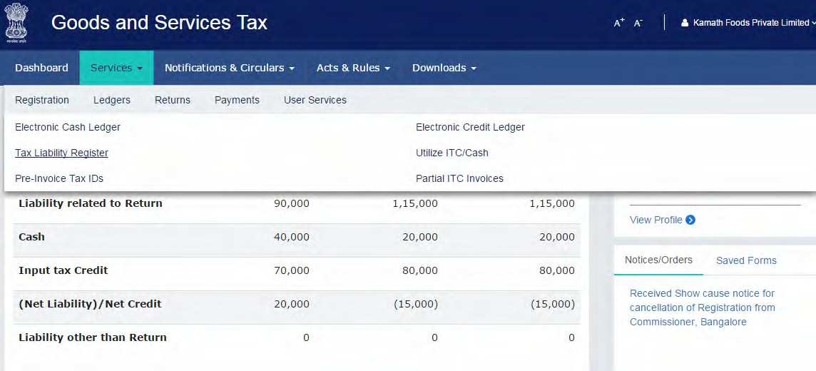

**Taxpayer logs into GST portal using their login ID & password**

**Taxpayer navigates to –**

**GST Services > View Ledger & clicks on Tax liability register**

###### Tax Liability Register

What happens when I click on Tax ledger?

* Landing page for Tax ledger will be displayed & it will contain
  1. Tax liability as on date
  2. Option to view return related tax liability and other than return related liability

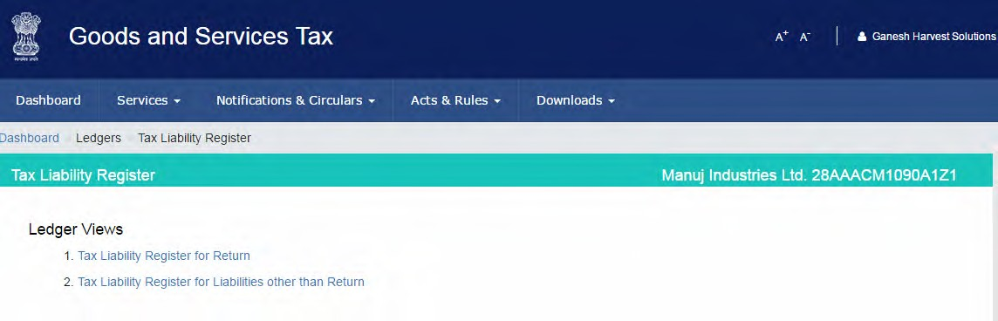

###### Tax Liability Register: Business Rules

1. Period selected for which the ledger can be viewed is < 6 > months
2. Tax Liability Register is not applicable for Government Department and UN Bodies having Government ID/Unique ID but no GSTIN.
3. No manual editing is possible in the Tax Liability Ledger.

###### Mismatch Reports

* + The purpose of this report is to capture the mismatch reported by the Supplier Taxpayer & Receiver Taxpayer.
  + The Mismatch Report will capture the details of all such line items of the invoices & will be available as a Report for the supplier and receiver Taxpayer’s information & convenience.
  + This system generated report will only be available for viewing & will not be liable for any manipulations by the viewer. The jurisdictional Tax Authorities will also be eligible to view the Mismatch Report.
  + Mismatch Report will be generated for every tax period on filing of valid GSTR 3 by the Taxpayer or 21st day of (M+1) whichever is later.
  + Communication will be sent to both the parties (Supplier & Receiver) on generation of Mismatch Report.

###### Mismatch Reports

What happens when I click on Mismatch Reports?

* Mismatch Report w.r.t. the Taxable supplies will be displayed:
* Supplier Mismatch
* Receiver Mismatch
* E-commerce Mismatch

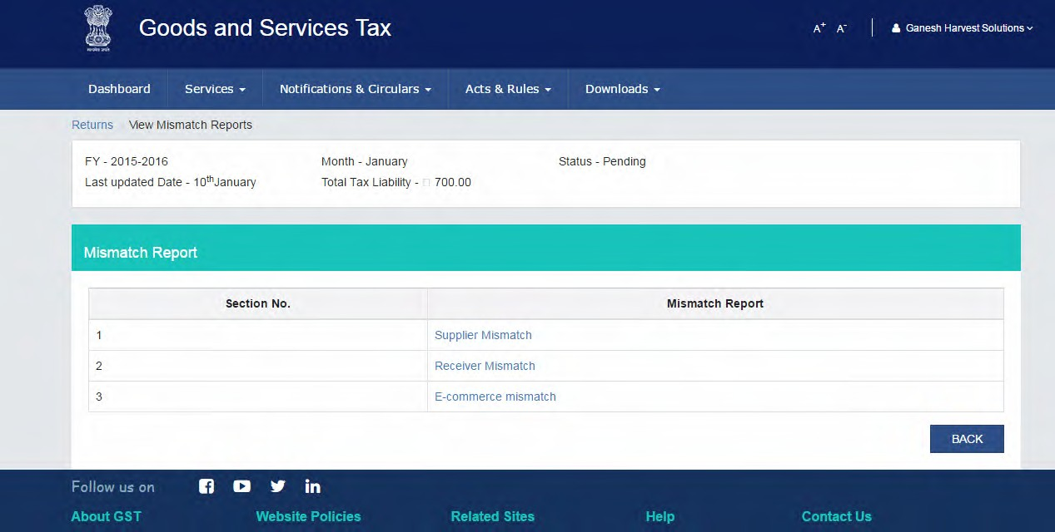

###### Utilising Cash & ITC

Payments for tax & other liabilities can be made from the following sources

Cash

Provisional ITC1

Existing ITC2

1. - ITC for current month
2. - ITC from previous months

###### Utilising Cash & ITC: Business Rules

Payment through CASH

1. The amount of Cash deposited for CGST/SGST/IGST/Cess can be used only for payment of CGST/SGST/IGST/Cess liabilities respectively. No inter-head adjustment is allowed for major-minor heads.
2. Cash deposited under the minor head i.e., Tax/Interest/Fee/Penalty/Others can only be utilised for payment of Tax/Interest/Fee/Penalty/Others respectively. It implies that no inter-head adjustment is allowed.
3. The amount allowed to be entered for utilization of cash can’t be more than the amount of balance available under the respective major/minor head of tax.
4. Amount under Cash Ledger will be used in the following priority order:
   1. Self-assessed tax, & other dues related to returns of previous tax periods;
   2. Self-assessed tax, & other dues related to return of current tax period;
   3. Any other amount payable under the Act or the rules made thereunder including the demand determined under section 66 or 67.

###### Utilising Cash & ITC: Business Rules

Payment through ITC

# IGST

**CGST SGST**

**IGST**

**CGST SGST**

Order of Priority

Page 55

“GSTN Internal Confidential”

.

**1**

**2**



Designed and Developed by GSTN



**THANK YOU!**